WELCOME TO HOLLAND
by Emily Perl Kingsley

I am often asked to describe the experience of raising a child with a disability- to try to help people who have not shared that unique experience to understand it, to imagine how it would feel. It's like this...
When you're going to have a baby, it's like planning a fabulous vacation trip -to Italy. You buy a bunch of guide books and make your wonderful plans. The Coliseum. The Michelangelo David. The gondolas in Venice. You may learn some handy phrases in Italian. It's all very exciting.
After months of eager anticipation, the day finally arrives. You pack your bags and off you go. Several hours later, the plane lands. The stewardess comes in and says, "Welcome to Holland."
" Holland?!?" you say. "What do you mean Holland?? I signed up for Italy! I'm supposed to be in Italy. All my life I've dreamed of going to Italy."
But there's been a change in the flight plan. They've landed in Holland and there you must stay.
The important thing is they haven't taken you to a horrible, disgusting, filthy place, full of pestilence, famine and disease. It's just a different place.
So you must go out and buy new guidebooks. And you must learn a whole new language. And you will meet a whole new group of people you would never have met.
It's just a different place. It's slower-paced than Italy, less flashy than Italy. But after you've been there for a while and you catch your breath, you look around... and you begin to notice that Holland has windmills... and Holland has tulips. Holland even has Rembrandts.
But everyone you know is busy coming and going from Italy...and they're all bragging about what a wonderful time they had there. And for the rest of your life, you will say "Yes, that's where I was supposed to go. That's what I had planned."
And the pain of that will never, ever, ever, ever go away... because the loss of that dream is a very very significant loss.
But... if you spend your life mourning the fact that you didn't get to Italy, you may never be free to enjoy the very special, the very lovely things ...about Holland.

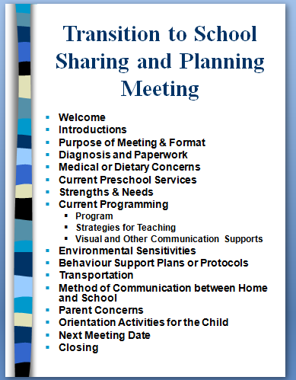
My Day Date______________

Today at school, I enjoyed_________________________.

One thing I learned about __________________________ .

During free choice I __________________________________.

At recess, I asked ___________________________to play.

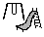 At recess, I played_______________________________.

I talked with _________________ and ___________________.

I talked with my teacher about __________________________
__________________________________________________.

News from School:_________________________________
___________________________________________________.

News from Home:__________________________________
___________________________________________________.
My Day Date______________

Today at school, I enjoyed______________________. ___

One thing I learned about _______________________. ___
I talked with _______________ and ____________. ___

During free choice I _________________________. ___

At recess, I asked _______________________to play. ___

At recess, I played___________________________. ___

News from School:_________________________________
___________________________________________________.

News from Home:__________________________________
___________________________________________________.
p prompted
+ independent
______’s Day Date______________

Today at school, ____enjoyed________________________.

We worked on:

Communication:_______________________________.

Math:______________________________________.

Language Arts:_______________________________.

Fine Motor:__________________________________.

Independent Activity System:____________________.

Today, ___’s buddy was:______________________________.

At recess, ____ played:_____________________________.

News from School:_________________________________
___________________________________________________.

News from Home:__________________________________
___________________________________________________.

