Recommended iPad Apps
Barry Hicks
Autism Itinerant
Newfoundland and Labrador English School District

- Make Sentences- Reading, Writing, and sentence construction 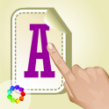

- Pic Collage- photos for visual schedule and social stories

- Fluid and Pocket Pond2- sensory 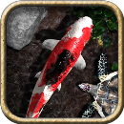
- I-Movie- videotape and edit to create personal social stories. 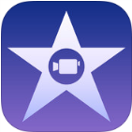

- POW- Make Comic Conversations with real pictures

- Bugs and Buttons-patterns, sorting, counting, and fine motor. 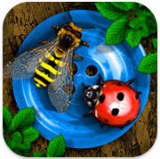

- Dexteria Jr.- Fine motor skills 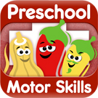
- More Fun Lite- following directions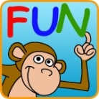

- First and Then(free)- Visual Schedule 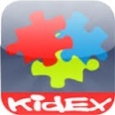
- Touch and Write- letter and numbers, sight words, fine motor 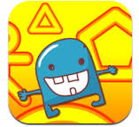

- Innervoice- communication 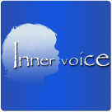
- I like Books- 37 books that can be read to the student 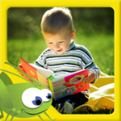
- ABA problem solving- visual discrimination
- Dot to Dot apps – fine motor, counting 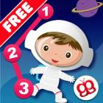
- Agnitus- shapes and matching 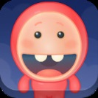
- Simplex Lite- Spelling 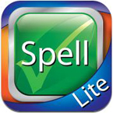
- Token Me 123 - token system/ choice/ rewards 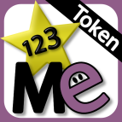
- Monkey Math and Multi I- Math facts 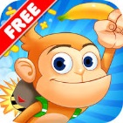 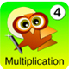

- Autism Apps- Search engine for autism related topics. 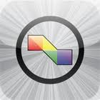
- Endless Reader- sight words, phonics, and sentence construction.
- Wordplay-reading 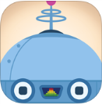
- Friends of ten and base ten blocks- number concepts 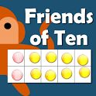 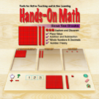
- Todo Math- math operations and number concepts 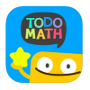
- iWordQ- IPad version of the Wordq software 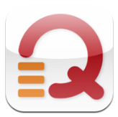
- Read Me stories- Early readers 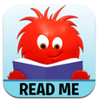
- ItubeList- you tube videos without the ads.
- Let’s Build- concept development
- Voice Meter- class noise or student voice control 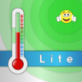
- Endless 123- Early math, counting 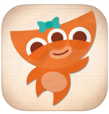
- Splash Math- graded math apps 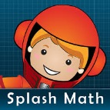 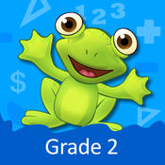

- Story Maker Free- writing 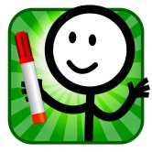
- Model Me Going Places- Social Stories
- Words and Blocks- sight words 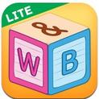
- Autism Help!- self -regulation
- Social Scale- self-regulation

- Breathe – self regulation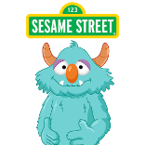

- ASD Tools-timer, reward system, first/ then, and schedule 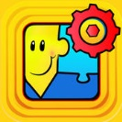
- Educreations- whiteboard with voice recording
- Endless Alphabet- phonics and sight words. 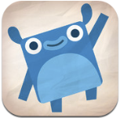
- See Me Go Potty- toilet training 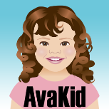
- Pepi Bath- grooming and routines 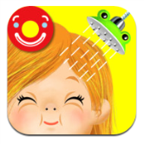
- Dragon Dictation- voice to text.
- PhotoMath- automatic equation solver 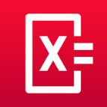
- Social Talks- tutorial app around socializing with others. 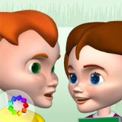
- Friendship Maker- PEERS program 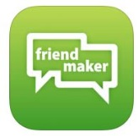
- Snap type- allows writing on a picture/ document. 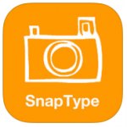
- AudioNote- voice recording 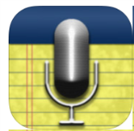
- Adobe Voice- writing templates 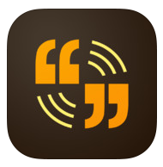
- Dream Voice or Natural Reader- text reading 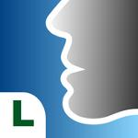 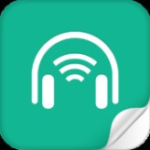

- Google Translate- language translation 